Board Conference Call Meeting Minutes
November 16, 2020

BOT ATTENDED:
Rev. Valerie Mansfield, Chuck Fulner, Jacque Saltsman, Dave Fralick, William Driscoll, Bill Kuntz, Mark Helm, Jeanne Bencker

GUESTS: Lettie Johnson and SteVon Edwards (Gifted By Design) and Todd Royer (Finance Committee)

CALL TO ORDER: 6:31 pm by Chuck Fulner

OPENING PRAYER: Rev. Valerie Mansfield

FINANCE COMMITTEE UPDATE:
- ATTENDEES: Rev. Valerie Mansfield, Todd Royer, Chuck Fulner, Dave Fralick
- ABSENT: Mark Helm, Bill Kuntz
- FULL UPDATE (see attachment)
- TOPLINE:
  - Potential savings if we reduce bank fees
  - Propose switching Generosity Giving Funds to General Operating Expenses
  - Todd Royer comments:
    - If we do nothing, could have a -$9,000 per month deficit
    - Biggest expenses are salaries and payroll taxes
    - Ask congregants to give more right now as a tax deduction before year end
  - Need more income; Cash from in person Sunday giving gone
  - Mark Helm indicated we need more committed giving and might suggestion we use the “subscription” model for giving
  - Current Committed Giving: ~$6,000 per month
  - Rev. Valerie Mansfield commented that:
    - Committed giving is down by ~$1,000 per month
    - Unity has had some unusual expenses at the beginning of this year
    - Two different nonprofit organizations are renting space from us: $600/month for one and love offering for the other
    - Suggested we look for other nonprofit organizations that might need space to rent
    - Charge a fee for Spiritual Direction and Energy Works for non-congregants; 3 appointments are usually the minimum
    - Suggested we call and talk to key congregants about giving more FIRST and then (if needed) switch Generosity Giving Funds for a month or two to General Fund
  - Chuck Fulner:
    - Finance Committee needs to verify numbers and get back BOT
    - Also agreed that we should talk to congregants about changing their Generosity Giving Funds (~$900/month) to General Fund
    - Personally did not want to cut back on outside musicians for Sunday Service
    - Summarized a 3 part strategy for giving:
      - 1). Board member to ask from Sunday Platform (Chuck Fulner volunteered)
      - 2). Put giving information in Holiday Newsletter
        - 3). If more giving is needed, call congregants who gave IRA to Generosity Giving Funds to switch one time to General Fund
    - Mark Helm to announce on a Sunday
    - Put 5 newly formed Committees in Holiday Newsletter and ask for volunteers
NEXT STEPS:
- Finance Committee to review budget numbers by next Board Meeting
- Rev. Valerie Mansfield to let Mark Helm know % of committed giving
- BOT to call congregants about giving. Who? When?
- Chuck Fulner to give an update from platform on finances (PPP gone, tithing down, class giving is very low and gap in income and expenses). When?
- Mark Helm to give an update from platform on committed giving (subscription model) when ready
STRATEGIC PLAN UPDATE:
- GBD toplined STRAT Planning session (11/7) (see attached)
- 3 Buckets to that Unity has been playing in around diversity:
  - 1). Diversity, inclusion and equity in society
  - 2). Our Facility
  - 3). Clarity of Board Profile
  - Mark Helm added a 4th bucket: Finances
- Need to dig deeper on lens on how we get there
- GBD recommended that a board member to lead Diversity, Inclusion and Equity Committee as the “Advocate”
- Jacque Saltsman indicated that we need to create the opportunities that don’t currently exist
- GBD indicate we need more D, I and E on board, staff, congregation, service, music, etc.
- GBD want BOT to fill out survey and consider D, I and E gaps for 2021 board elections
- Had 20 minute breakout session for the committees to start brainstorming for STRAT Plan
- Had BOT self-elect from 5 committees to serve on
- Here are the 5 committees:
  - 1). Raised Consciousness (Rev. Valerie Mansfield, Bill Kuntz
  - 2). Sell Building (Chuck Fulner)
  - 3). Diverse Community Education and Outreach (Jacque Saltsman and William Driscoll)
  - 4). Gifts and Giving (Mark Helm, Todd Royer and Jeanne Bencker
  - 5). Diversify Leadership, Staff and Congregation (Dave Fralick)

NEXT STEPS:
- Each committee to meet over the next 1-3 weeks to further develop goals
- Each committee to submit plan to GBD by 12/4
- GBD will culminate goals and distribute to BOT by 12/14 BOT meeting
- Chuck Fulner to generate message
- Jacque Saltsman and William Driscoll to edit message

APPROVAL OF AGENDA:
- Bill Kuntz
- Rev. Valerie Mansfield
Approved: Unanimous

APPROVAL OF MINUTES:
- Rev. Valerie Mansfield
- Bill Kuntz
Approved: Unanimous

LOAVES AND FISHES GRANT APPLICATION:
- Initially, Unity of Louisville not qualified for grant due to receiving PPP
- Now, there is still money left in grant
- Unity of Louisville can apply for $2,000
NEXT STEPS:
  - Mark Helm volunteered to fill-out grant application

MINISTER’S REPORT:
- See Attached
- Need to consider ways to give that have little or no fees, i.e., bank drafts have no fees will credit cards carry significant fees
- Potentially call congregants that give with highest fees to switch to a no fee way of giving
- Spectrum internet was changed that has double the speed and cost $8 less per month
- Sunday Service viewership is increasing every week

TREASURER’S REPORT:
- See attached
- NOTE: 5 weeks of payroll in October
- Hourly wages going up to $15/hour
CALL TO ADJOURN:
- William Driscoll
- Mark Helm
UNANIMOUS

PRAY-OUT: Rev. Valerie Mansfield

ADJOURNMENT: 8:34 pm

HAND-OUTS
AGENDA
UNITY OF LOUISVILLE
November 20, 2020
Board of Trustees Meeting 6:30 – 8:30 pm

Vision Statement:
Unity of Louisville is an inclusive, prosperous, compassionate community celebrating Oneness and infinite possibilities.
Mission Statement
We transform ourselves and the world through Love.

Call to Order

Opening Prayer & Meditation

Approval of Agenda

Strategic Plan Update (with guests)

Check In

Approval of Minutes

Minister's Report

Treasurer's Report

Finance Committee Update

Loaves and Fishes Grant Application

Adjournment and Closing Prayer

MINISTER’S‌ ‌REPORT‌ ‌
Rev.‌ ‌Valerie‌ ‌Mansfield‌ ‌
November 16, ‌ ‌2020‌ ‌

WEDDINGS, FUNERALS, CHRISTENINGS, VISITATION
Funerals/Memorials: 0/0
Hospital/Visitation/Social/Spiritual Direction: 0/1/2/4
Weddings/Christenings/House Blessings: 0/0/1

Worship
- We are finishing up our series on The Power of Song. Yesterday’s service reached over 2300 by 9am this morning and the views are over 1100 with 100 comments. Great job to the team. During the service we had 54 folks viewing at one time.
- The Spirit of Christmas is the theme for December. We will be focusing on the Christ unfoldment within each of us. Through our practices and spiritual growth we rise in consciousness into our power of Oneness.
- The Outdoor Services at East are on hold until the Covid-19 number begin to decline again.

Building Updates
- We have 3 active leaks in the roof where the two buildings connect and in the classroom area. I have asked the building team to handle the roof.
- The City of Refuge Ministry will begin using the Activity Center on Sunday's to record their live service, use of one of the offices in the school area. When Covid restrictions are down they will have their young adults meet two Thursday nights a month. They are planning to begin moving their equipment this week and start using the facility on November 22. We are receiving $600 a month and $300 for November. This is a temporary arrangement through Covid.
- We are partnering with the Hope Bus to feed the houseless, in the area. Rev. Stacell Burgess will be using the other office in the school area, as needed. She put me in touch with the City of Refuge and another church looking for recording space.

ADMINISTRATIVE UPDATES
- The finance committee met and will be making recommendations for us going forward. We reviewed the draft budget for 2021. I am requesting the funding to hire Treavor Fralick to handle our accounting.
- Our computer desktop computers are old. The one housing QuickBooks shuts down every time we run payroll. It has to be replaced within the next few weeks. I am concerned that it will crash and be unrecoverable. We will lose all our financial information. We do not have enough space to backup QuickBooks. I suggest we move to QuickBooks online, now.
- Since I contacted the city regarding the no trespassing ordinance on file people are gone in the morning before I arrive. They continue to use the restroom all ‌

Thanks‌ ‌to‌ ‌each‌ ‌of‌ ‌you‌ ‌for‌ ‌being‌ ‌Love‌ ‌and‌ ‌Light‌ ‌and‌ ‌sharing‌ ‌who‌ ‌you‌ ‌are‌ ‌with‌ ‌Unity‌ ‌of‌ ‌Louisville.‌ ‌
‌ ‌
MINISTER’S‌ ‌REPORT‌ ‌
Rev.‌ ‌Valerie‌ ‌Mansfield‌ ‌
November 16, ‌ ‌2020‌ ‌
‌
over the property. We have feces everywhere. The encampment is scheduled to be moved by November 18.
- I continue to pick up the mail from the post office
- Robert Bagley is working to update the member directory in Servant Keeper. Once it’s complete Sabrina will upload the member directory to the member page. The target date is late January.
- Elaine is working on creating a holiday newsletter. I will be including information about the holiday schedule and picking up of supplies for the upcoming special services. Chuck is adding information on the finances, building and strategic planning.
- We celebrate 110 years of Unity in Louisville this month.
- Staff continues to work from home for the most part. The exception being myself, Aaron and Bethany.

SOCIAL, EDUCATION, MINISTRY TEAM UPDATES
Adult Education
- The Non-Violent Communications group meets every other Tuesday through January.
- We have a Seven Day Gratitude Challenge which starts on November 18. Participates are required to sign up to participate. The daily challenge will be emailed to participants.
- I will be facilitating Reiki 1 & 2 weekend in January on Zoom.
Youth & Family Ministry
- We cancelled the in-person Youth & Family Sunday meetings through the end of the year because of the rise in Covid numbers.
- Trunk or Treat at Unity of East Louisville was a blast for the youth and families. Leah and Chelsea did a great job organizing it. They even had neighbor children participate.
Sacred Ministry
- Rev. Gwen is continuing to work with the chaplains to redesign the program to meet the community's current needs.
- Gwen and Alan both have the list of folks both members and regular attendees, to call or send cards.
- Elaine is waiting to talk with Alan regarding the postcard mailing. This will happen after the first of the year. Possible during Lent.
- Faith and Alex are recording the Daily Word. Alex asked if they can recruit others to record too. I said yes. Whatever they decide is fine.
- I am working with the SAFY group on Eastern Parkway to bring energy works to their clients. Folks can sign up on our website for Spiritual Direction and Reiki/Energy Works appointments.

Thanks‌ ‌to‌ ‌each‌ ‌of‌ ‌you‌ ‌for‌ ‌being‌ ‌Love‌ ‌and‌ ‌Light‌ ‌and‌ ‌sharing‌ ‌who‌ ‌you‌ ‌are‌ ‌with‌ ‌Unity‌ ‌of‌ ‌Louisville.‌ ‌
MINISTER’S‌ ‌REPORT‌ ‌
Rev.‌ ‌Valerie‌ ‌Mansfield‌ ‌
November 16, ‌ ‌2020‌ ‌
‌

- I am working with another Spiritual Director who is located in Florida. Tim Alderman is on the Board of Unity Worldwide Ministries with me and is willing to meet with folks too. The number of appointments for Spiritual Direction has been on the increase and I am anticipating more as we let folk know how to sign up.

Prayers/Transitions/Milestones
- Artus Fox was transferred to rehab.
- Glenn Walters made his transition two weeks ago.
- Sybil Temple’s mother passed away.
- Alan Scherer's mother is in the hospital. Bruce had heart surgery and is recovering at home with Alan.
- Warren Stone is creating a community Wooden Barn Quilt for the church. On Saturday, we had a group activity painting different parts of the quilt on Zoom. Warren and Kurt delivered the supplies to everyone. Hope showed a slideshow of Warren on the Kentucky Wooden Quilt Barn Trail, this summer. It was great fun to be together. Don Reinhardt assisted with cutting the wooden triangles.

Thanks‌ ‌to‌ ‌each‌ ‌of‌ ‌you‌ ‌for‌ ‌being‌ ‌Love‌ ‌and‌ ‌Light‌ ‌and‌ ‌sharing‌ ‌who‌ ‌you‌ ‌are‌ ‌with‌ ‌Unity‌ ‌of‌ ‌Louisville.‌


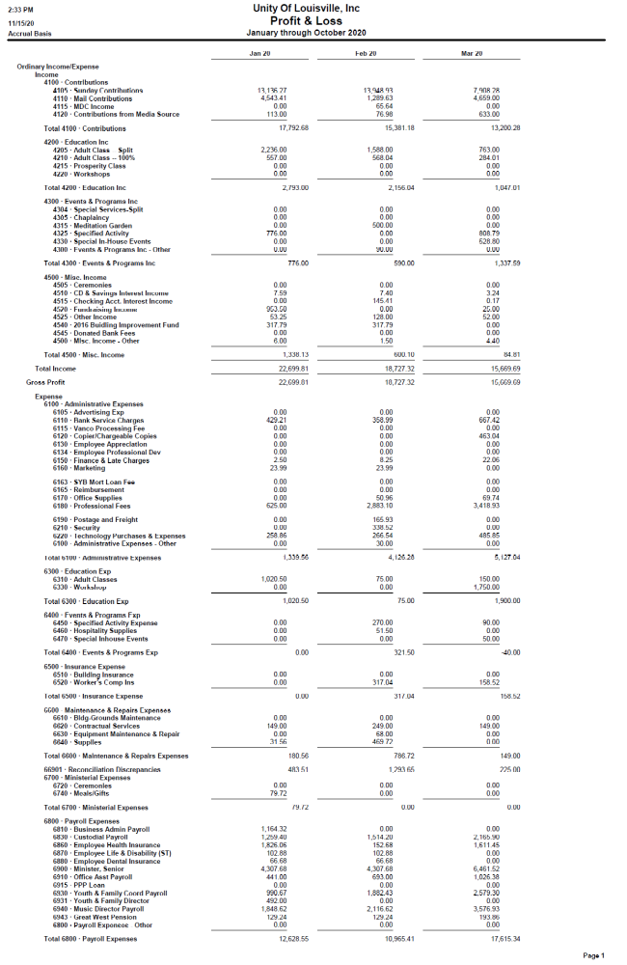
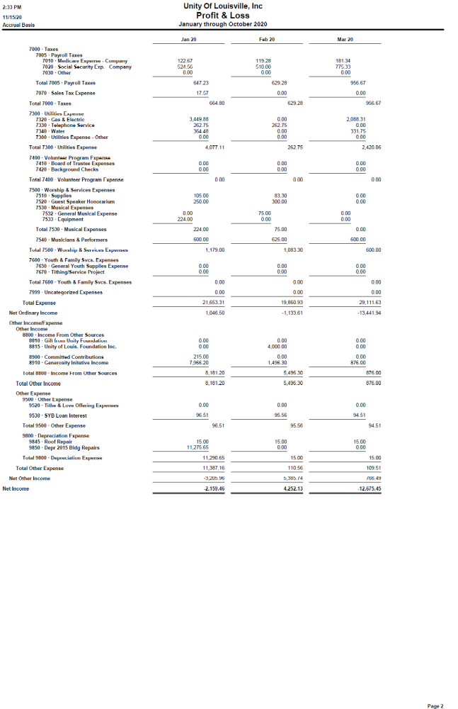
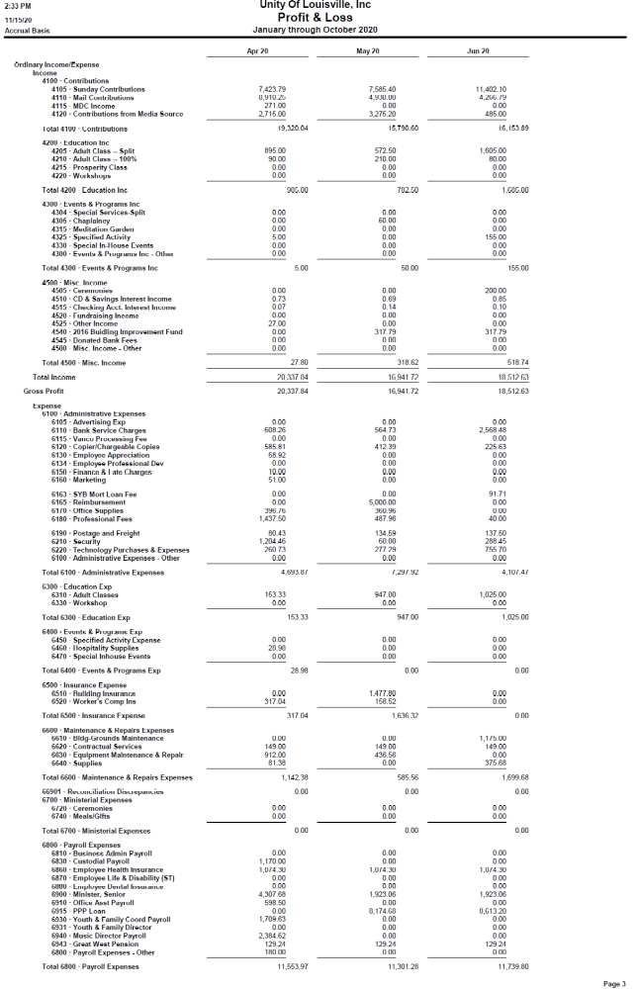
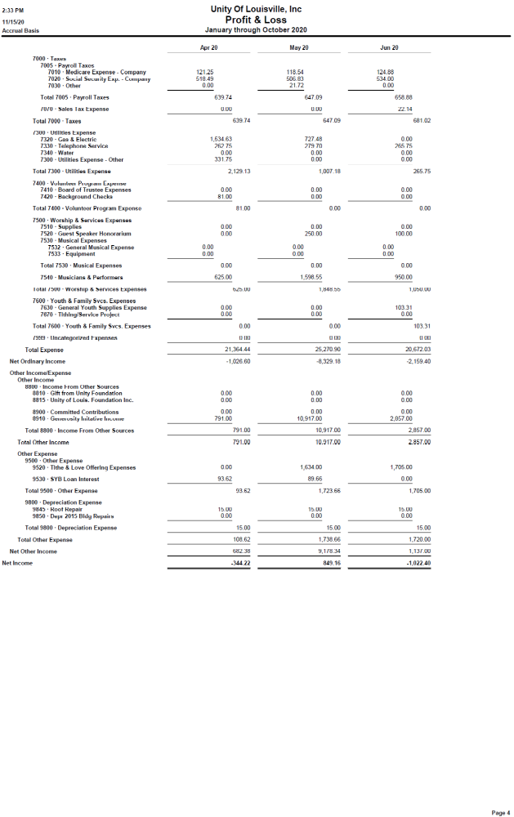
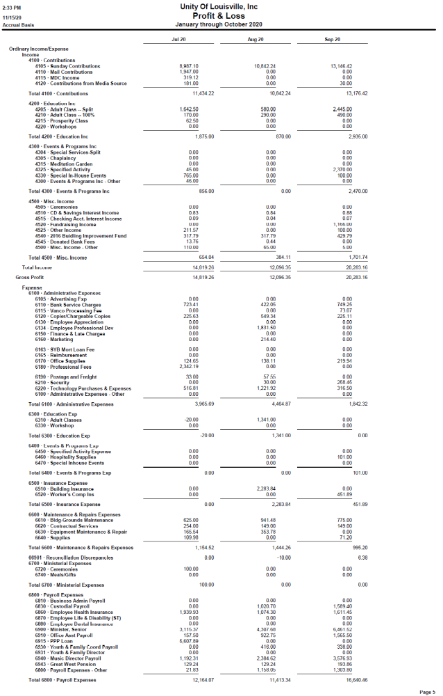
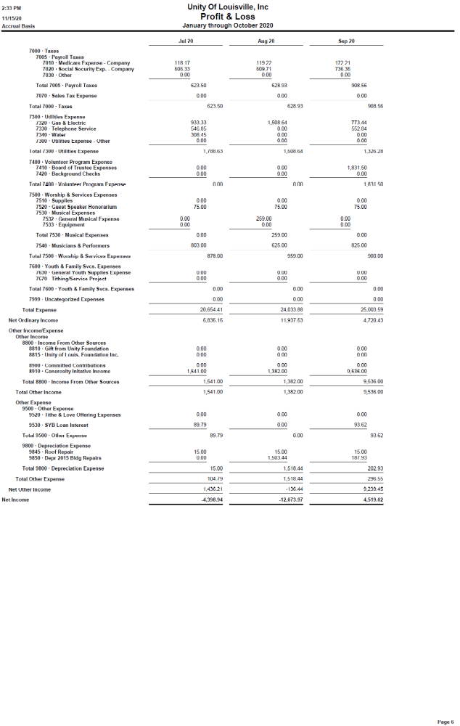
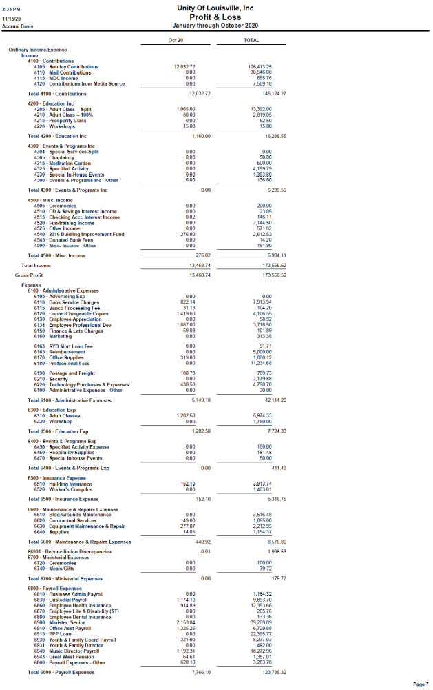
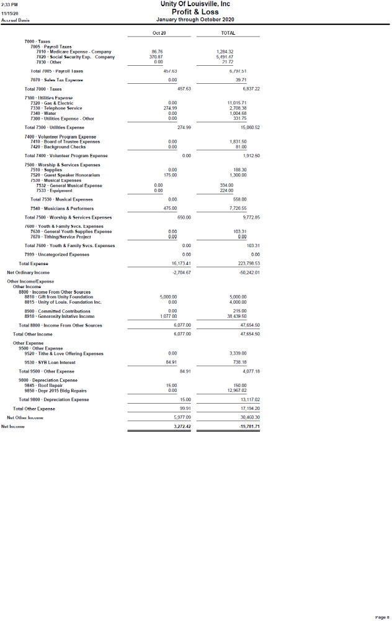

Finance Committee Update 11/11/20

In preparation for the 2021 Budget cycle and to review our current cash management practices, the Finance Committee met Monday evening. Here is a summary of our findings and conclusions.

(1) Like many churches in Louisville and most Unity congregations, COVID hit us hard. Our decision to shut down in person services had a significant negative impact on our income. In person donations in cash and checks went away and haven't been replaced in anywhere near amounts from other sources.

Donations generated by Gerry Boylan's Sunday Morning classes, which were predominantly cash, are below pre-COVID levels as well. We split those donations on a 50/50 basis.

Even before the COVID crisis hit, the Generosity Campaign had a discernable impact on giving as some members reduced their regular giving in part as they began making those donations.
Over all giving is less than what it was prior to the COVID related shut down,

(2) After a few delays, we were able to set up online giving processes through our website which a growing number of congregants use. We obtained a Payroll Protection Loan through the assistance of Stock Yards Bank which covered our payroll for several weeks as well as a few other allowable expenses. However proceeds from that Loan are exhausted and the Program has not been extended by additional legislation. As a side note, the original loan is forgivable under certain criteria. We have just started that process and we are highly confident that repayment will not be required.

(3) Our initial projections for the 2021 Fiscal Year that starts 1 January included the following assumptions and aspirations:
(a) There will be no changes in Income;
(b) Rev Val will not have to act as our bookkeeper.
(c) All of our staff will be retained at the current number of hours worked and at an hourly wage of $15.
(d) Rev Val and Phil Crowther our two salaried staff, would stay at their current pay rates and with current benefits. All of our other expenses would stay at current levels 9last three months) because we have reduced those expenses as much as possible.

(4) The combination of assumptions and aspirations cited at (3) above would produce an unsustainable monthly deficit of $9,000.

(5) Here are the next steps the Finance Committee recommends:
(a) Keep salaries and wages at current levels.
(b) Reduce staff hours on the margin in a method to be decided by Rev Val.
(c) Ask all current givers who use credit cards or other payment methods that generate Bank Fees for the Church to switch to donation methods that do not generate fees or cover those fees by a marginal increase in donation amount.
(d) Ask Phil to use fewer outside paid musicians on a temporary basis.
(e) Ask those individuals who make contributions to the Generosity Fund to temporarily make those donations to the General Fund instead and resume their Generosity donations after our building is sold and we have decided what to do next about our real estate needs.
(f) Follow up on all opportunities to rent the Activity Center to other Churches seeking a new home.
(g) When we have a clearer picture of our financial status, but certainly no later than early December, ask our members to prayerfully consider an increase in their regular giving,






